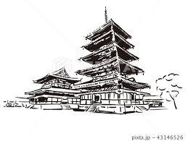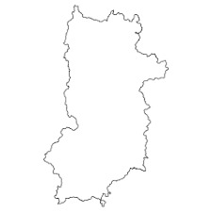

|  |  |  |  |  |
| --- | --- | --- | --- | --- |
| １ |  |  |  |  |
| ２ |  |  |  |  |
| ３ |  |  |  |  |

**キャリア**

**パスポート**

学校